Unit 3: Lesson 15
The Buck Stops Here!

Goal: To learn that the social and emotional positive actions of managing our money and managing our possessions help us feel good about ourselves.

NOTE: Before presenting this lesson to the family, parents should do the “Parents Positive Actions” section and prepare a family budget. You will use the family budget in this lesson.
parent positive actions

Ask Yourself: How do you manage your personal spending money? What changes would you like to make? How does the way you manage the family income make you feel about yourself? What changes would you like to make? What are you teaching your children about managing money? About managing possessions?
Plan and Do: Practice the positive actions of managing your money and possessions by setting up a budget. Or review your budget if you already have one.

To set up a family budget, determine your family’s monthly income. Then use the chart after this section to help you determine your family’s monthly expenses. Be sure to include the following categories, and add your own as needed:
- Food
- Rent/mortgage
- Utilities (electricity, phone, heat, water, waste disposal, etc.)
- Medical/Dental (doctors, hospital, prescriptions, insurance, etc.)
- Transportation (car, bus fare, train)
- Insurance
- Clothing
- Childcare
- Education (School fees, music lessons, classes, workshops, etc.)
- Household (repairs, landscaping, etc.)
- Allowances
- Gifts/donations
You will add some other categories during the FAMILY POSITIVE ACTIONS portion of the lesson.
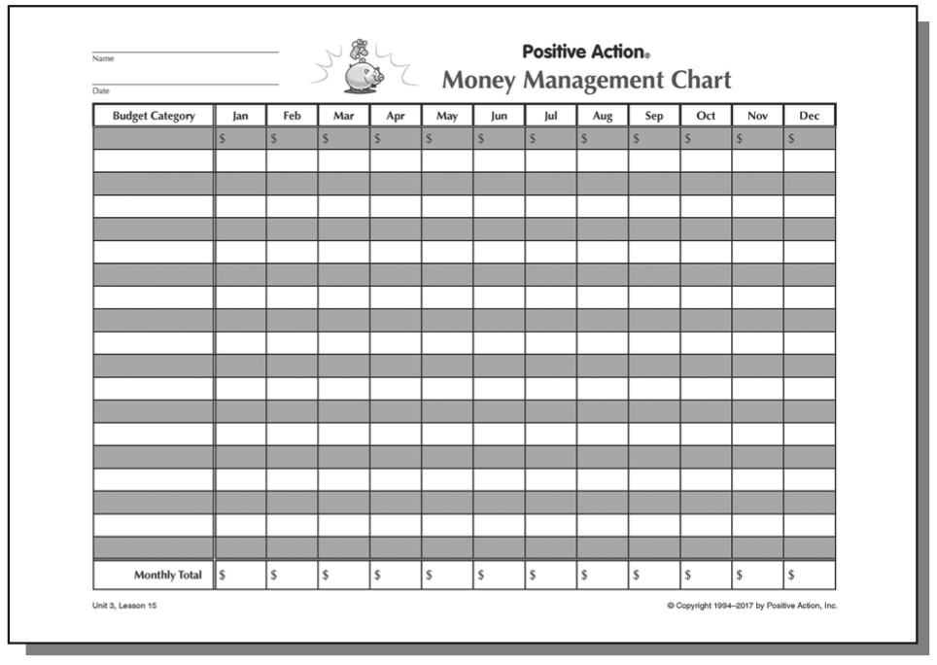
STORY:
“Your total comes to $39.43.”
Aaron smiled to himself as he handed the grocery clerk two $20 bills. He had done it! He had bought only the items on his grocery list. There were no chips, no dip, no candy bars, no lottery tickets, and no soda in his basket this time. Aaron was learning to manage his money positively, and his successful shopping trip made him feel good about himself.
Several of Aaron’s friends earned less than he did, but they seemed to have everything they needed and did the things they wanted to do. Frustrated by his own lack of money, Aaron finally asked Rosa how she managed it. Happy that her friend asked for help, Rosa shared her methods for budgeting her income and expenses. Now a budget was working for Aaron, too.

Managing our money and managing our possessions are positive actions that help us feel good about ourselves. It’s important for our self-concepts that we manage our money and possessions as well as possible. Managing them is not hard, but it does take time, commitment, and discipline. Our goal is to manage them so they don’t manage us, as so often happens when spending is out of control.
Managing Our Money. We all want money. It is a means to do good for ourselves and others. But being greedy, gambling, or making money for money’s sake can make us unhappy. We have a responsibility to manage our money in a way that enables us to take care of ourselves and share with others when we have extra.
The best way to manage money is to have a budget. A budget is a tool that helps us keep track of our income (what we make) and our expenses (what we spend). It lets us know how much money we have after we pay our bills.
Setting up a budget is not as difficult as many people think. We begin by gathering information. First, we determine how much money we receive each month: our income. Next, we figure our expenses: how much it costs us to live each month.
The attached chart can help us determine our expenses. It provides a place to list the money we pay for housing, insurance, utilities, food, clothing, personal needs, and transportation. We should also include other recurring expenses such as credit card payments.
Saving some of this money each month is good money management and can be included as a monthly expense. Savings can keep up from going into debt during an emergency or when we need to purchase larger items.
Then we subtract our expenses from our income. The amount left is our “spending money.” It can be used for whatever we choose. How we spend this money depends on our needs and wants. Planning to spend money wisely is a positive action.

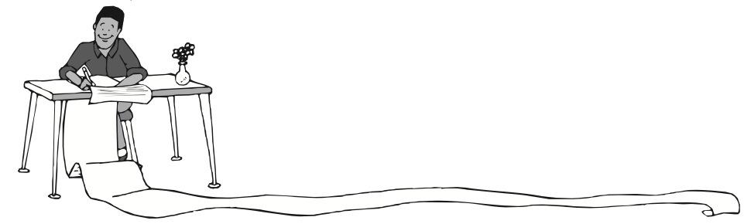

When we spend money, we have a responsibility to our family and to those around us. By taking this responsibility seriously, we are inclined to spend our money on things that benefit all of us. We are also inclined to share generously with others when we have more than we need. We won’t spend money on alcohol or other drugs or on other negative activities such as gambling if we consider how they harm us and others.
By managing our money responsibly, we avoid spending more than we have. We should never take money that is not ours unless someone specifically gives it to us. Following a budget helps us stay within our spending limits and prevents unnecessary debt. Budgets serve as guidelines to help us manage our money successfully. We feel good about ourselves when we are in control of our money.
Managing Our Possessions. Possessions are the things we own. Managing them responsibly frees us from being controlled by them. If we are spending too much time and money on our possessions, then they are controlling us. Out goal should be to manage our possessions in ways that enable us to feel good about ourselves and to share our extra possessions with others.
Taking care of what we already own helps us avoid unnecessary replacement costs. Rather than having to buy the same things over and over, we can use our future income in more beneficial ways. Managing possessions also includes disposing of them properly when we are finished with them. Giving usable, surplus possessions to charities or those in need is a way to share our extra resources with others. Part of managing possessions is respecting other people’s possessions and possessions we share in the community. We don’t take or damage these, just as we wouldn’t want anyone to damage our personal possessions.
One of the easiest ways to care for our possessions is to put them away after we use them. Picking them up prevents them from getting broken and keeps all the parts together. Some possessions, such as home appliances and cars, need to be services or repaired from time to time. Servicing them is easier when we budget money for their care and set up a regular maintenance schedule.
Our money and possessions actually represent other resources in our lives. They are frequently the results of how we manage our time, energy, talents, thoughts, and actions. Our money and possessions supply us with the means to do things. We are able to do more of the things we want when we take responsibility to manage them in positive ways. Controlling our money and possessions rather than being controlled by them enables us to use our money and possessions in positive ways ourselves and to share anything extra with others. Let’s manage our money and possessions so they don’t manage us.

QUESTIONS:
- Why is it important to manage our money and possessions?
- How can we mange money in a positive way?
- What is a budget?
- How does a budget work?
- What are some ways to manage our possessions?
- How does the way you manage your money make you feel about yourself?
- How could a personal budget help you manage your money?
- What are you saving for?
- How does the way you manage your possessions make you feel about yourself?
- What changes in the way you manage your possessions could make you feel better about yourself?

Let’s set up a personal budget by figuring our individual monthly income and determining our individual expenses. You can use the same chart as before.
Think how changing your spending habits would improve the way you feel about yourself. Then commit yourself to making those changes.
If you don’t have a savings plan, start one. Decide how much you can afford to save each month. Arrange to go to a savings bank and open an account this week. If that doesn’t seem feasible, what is a way you can save something, even a little? Could you collect your change? Let’s try to save something!
Now look at how you take care of your possessions. Train yourself to put your possessions away after you use them. Notice that it takes only a few minutes to put them away, but the feeling you get about yourself lasts much longer.

FAMILY POSITIVE ACTIONS
QUESTIONS:
- Why is it important to manage the family income?
- How could we manage our family’s money better?
- What changes would we make in our family’s spending habits?
- How could we make our possessions last longer?
- What additional possessions do we want?
Let’s make a family plan to practice the positive actions of managing our money and possessions. We’ll start by looking at the chart we have already filled out. It shows how much it costs for our family to live. Now let’s talk about how to use the family’s spending money. First, we need to decide how much money to save each month. Then we’ll talk about the purchases we would like to make and about what things we would like to do for fun.
Now let’s pick four or five items we want or need to purchase and list them below our regular expenses on the chart. These items are now included in our family budget. When we have the money available, we’ll use it to make these purchases.
From now on let’s refer to our budget before we spend our money to make sure we are spending it wisely. And let’s also manage our money wisely by taking care of our possessions.

COMMUNITY POSITIVE ACTIONS
We can also practice managing money and possessions in our community. By managing ourselves and our community’s possessions in positive ways, we can cut down on our community’s expenses. We could also attend a community budget meeting to learn how public funds will be spent.
We might want to help our community become more beautiful. We could support anti-graffiti campaigns or neighborhood beautification projects. If one isn’t already organized, we could organize it ourselves!

SUMMARY
Aaron likes the effect his budget is having in his life. He smiles when he thinks of the reason he didn’t start one earlier. He felt it would keep him from doing what he wanted to do. But to his amazement, his budget actually brought freedom – freedom from wasteful spending, freedom to choose what he wanted to do with his resources. He now has more money to spend on things he really wants. And he feels good about himself as he manages his money in positive ways.
Our goal should be to manage our money and possessions in positive ways that will make us feel good about ourselves, too. Managing money and possessions is not hard but it does take time and discipline. A budget can help us see which changes will improve the way we manage our money.
Properly caring for our possessions and keeping them picked up increases their usefulness and decreases our replacement costs. By doing so, we have more money available for other things, including helping others and giving to worthy causes whenever we have extra to share. Taking responsibility to manage our money and possessions in positive ways enables us to take care of ourselves and improves our self-concepts.
Words of the Week:
Possessions
Things you care for.
Money
Coins and bills.

